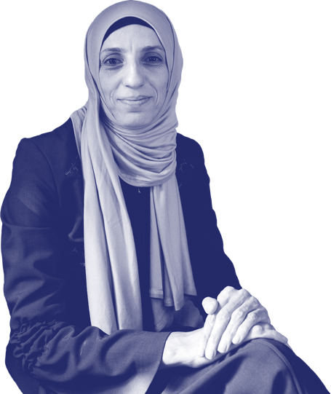
Strategy2028
MA Consultation Form
“The best way to understand the changing world is through the MAs.”
MA Director, 2021

MA Name:
Country:
Submission Date:
Submitted by:
Email:

Guidance (read first)
IPPF is in the final years of its strategic period. The process to design a new strategy started in December 2020 and will run until the General Assembly meeting in November 2022.
The IPPF Member Associations (MAs) are primary stakeholders in the design process. The strategic design must be shaped by MA knowledge and experience of a changing world and the opportunities it offers.
The primary purpose of this consultation form, which is one of several avenues to inform the strategic design, is to scan the national, regional, and global SRHR horizons. Doing so will help to inform the strategic choices we will make.
It will be up to each MA to decide how to collate and distil the information. It can be done, for example, via facilitated meetings, focus group discussions, zoom calls, internal surveys, email feedback, or the like.
It is important to include perspectives and voices from the Member Association, and in particular youth volunteers and the clients we serve. We have marked sections that benefit from their input in light blue. Other voices can also be included.
When filling in the form, please try to reflect the diversity of opinion and ideas expressed during your consultations. If you have different or opposing views expressed, you can consider including them both.
The form contains a structured questionnaire with open-ended questions. Your input should be distilled down to clear, single-sentence answers. We have provided some examples of answers under some of the questions. These are for guidance only. Clear and concise answers are important to ensure that the Secretariat can understand and analyse the large amount of information received through these consultations.
The form should be returned in an editable word format no later than 31 July 2021. Please send the filled in form to Strategy2028@IPPF.org
Please note that the consultation form is aligned with the new Business Planning tool used for the Stream 1 (core funding) 2022 application process. Filling in this form will make it easier to complete the Stream 1 application form. The Business Planning form is due in July 2021.

  - Section 1: MA Voices
Guidance: Please describe here who was included in the consultation, and in what format it was done. Please include gender composition and age were possible. Example: Focus group discussion, Zoom call, survey input, etc.
Who | How
MA Governance
MA Staff
Youth Volunteers
MA Clients
MA Partners
Add as required
  - Section 2: MA Context
Guidance: Please condense your input into individual sentences as per the examples provided. For sections (in blue), please try to consult clients, youth volunteers or other relevant stakeholders.
- Service Gaps | What are currently the main SRHR service gaps in your country?  Example: CSE not included in education curriculum and only provided through a few civil society organizations in the country  - …  - …  - …  - … (add lines as needed)
- Barriers | Describe what are currently the key barriers to achieve SRHR for all in your country.  Example: Access to abortion care is limited by laws and policies in the country, resulting in young women especially disproportionally affected by restrictions on abortion services.  - …  - …  - …  - … (add lines as needed)
- CSO Strategies | Describe the strategies put in place by civil society organizations to address the above barriers.  Example: Several CSOs have developed a joint SRHR advocacy strategy aiming to inform government decision makers and increase the grounds where abortion is legally accessible.  - …  - …  - …  - … (add lines as needed)
- Contribution | Describe in what ways you are contributing to the delivery/implementation of these strategies.  Example: We are leading a national coalition of like-minded CSOs and increased visibility for key advocacy messages through regular engagement with decision makers.  - …  - …  - …  - … (add lines as needed)
Section 3: MA Horizon
Guidance: Please condense your input into individual sentences. For sections in blue, please try to consult clients, youth volunteers or other relevant stakeholders.
- Policy & Legal Environments | What are the key SRHR advocacy / policy issues that your organization will address over the coming decade?  - …  - …  - …  - … (add lines as needed)
Describe how you will address these issues.
- …
- …
- …
- … (add lines as needed)
- Clients | Looking at the coming decade, describe who your main clients will be.  - …  - …  - …  - … (add lines as needed)
What services will they require?
- …
- …
- …
- … (add lines as needed)
Describe how they will access services in the future.
- …
- …
- …
- … (add lines as needed)
- Funding | What do you expect to be your main sources of funding in the coming decade?  - …  - …  - …  - … (add lines as needed)
What will be the biggest funding challenges you will face in the future?
- …
- …
- …
- … (add lines as needed)
Describe what opportunities will there be for expanding your funding in the next ten years.
- …
- …
- …
- … (add lines as needed)
- Structure | Describe what structural changes are required to prepare your organization for the future and to meet the needs of your future clients.  - …  - …  - …  - … (add lines as needed)
Describe in what ways your governance can be improved.
- …
- …
- …
- … (add lines as needed)
Section 4: Federation
Guidance: Please condense your input into individual sentences. For sections in blue, try to consult clients, youth volunteers or other relevant stakeholders.
- Horizon | Looking at the global horizon, describe what will be the issues that are most likely to define SRHR in the coming decade.  - …  - …  - …  - … (add lines as needed)
In what ways can we move SRHR beyond Cairo / ICPD?
- …
- …
- …
- … (add lines as needed)

Describe new innovations (medical, service delivery or other) that IPPF needs to consider in the new strategy.
- …
- …
- …
- … (add lines as needed)

What core values should inform our next strategic framework?
- …
- …
- …
- … (add lines as needed)
10. Federation Support | What specific support do you expect to receive from the IPPF Secretariat in the coming decade?  - …  - …  - …  - … (add lines as needed)
What should the IPPF Secretariat do differently in the future?
- …
- …
- …
- … (add lines as needed)
What should IPPF’s Board and Committees do differently in the future?
- …
- …
- …
- … (add lines as needed)
What does the term an “MA Centric Federation” mean to you?
- …
- …
- …
- … (add lines as needed)
Section 5: Other Comments
Guidance: Please include other important points and suggestions raised during your consultation/conversations.
Other comments and suggestions | - …  - …  - …  - …

The term IPPF refers to the full federation, i.e., the members and the Secretariat.

